CHAPTER VI

# Narrating Data

Data narration is more than simply describing data. It is user-centric through its focus on addressing the main questions of the audience and presenting information in a way that is easy to comprehend. Beyond that, it leaves an impression on readers by presenting information that shows them a pattern they may not have known or noticed on their own.

There are a few key questions to ask yourself as you start to narrate data:

1. Who is your audience?
2. What type of information are they seeking?
3. What are the main questions they are seeking to answer?
4. What narration formats (reports, tables, charts, infographics, numbers, statistics, verbal explanations) are they familiar with?

In order to illustrate an example of narrating data, this section will go through the process of writing the Donor and Development Assistance (DDA) landing page for the Open Development Mekong (ODM) website. Keep in mind that each narration you are designing is unique - this is only one example of approaching data narration.

Steps to creating the DDA landing page:

1. *Define the audience.* Initially, the landing page will provide basic information about major donors and trends in development assistance. The audience will likely be development professionals who are interested in learning about donor trends over time.
2. *Determine what information the audience is seeking.*Think about why your target audience has navigated to your page. What information are they seeking? Defining the key questions will guarantee that only the most important and relevant information is presented and all major points are covered in the overview. Answer these questions in the overview in order of importance to the audience. We defined the key questions for the DDA landing page as:
   1. *What projects are currently receiving the most funding? Why?*
   2. *Who are the biggest donors to the region?*
   3. *How important is donor assistance to countries’ economies?*
   4. *How is ODA changing over time?*
3. *Research the answers to the questions.* Where you research will depend on your research question and the questions of your audience. Look for reliable sources: avoid advocacy groups that may provide biased commentary and find sources that provide up-to-date data and data that is updated regularly. (See *Research 101* section for research tips).
4. *Present the answers with a narrative format familiar to the reader.* Think of how each question is best answered. Should it simply be a text explanation, or should visuals be used? What can be used to give numbers perspective and help the audience grasp the magnitude? When the answer requires context and explanation, a text answer may be best. For example:

* “*What projects are currently receiving the most funding? Why?”* is answered through text. It requires some explanation of regional context.
* 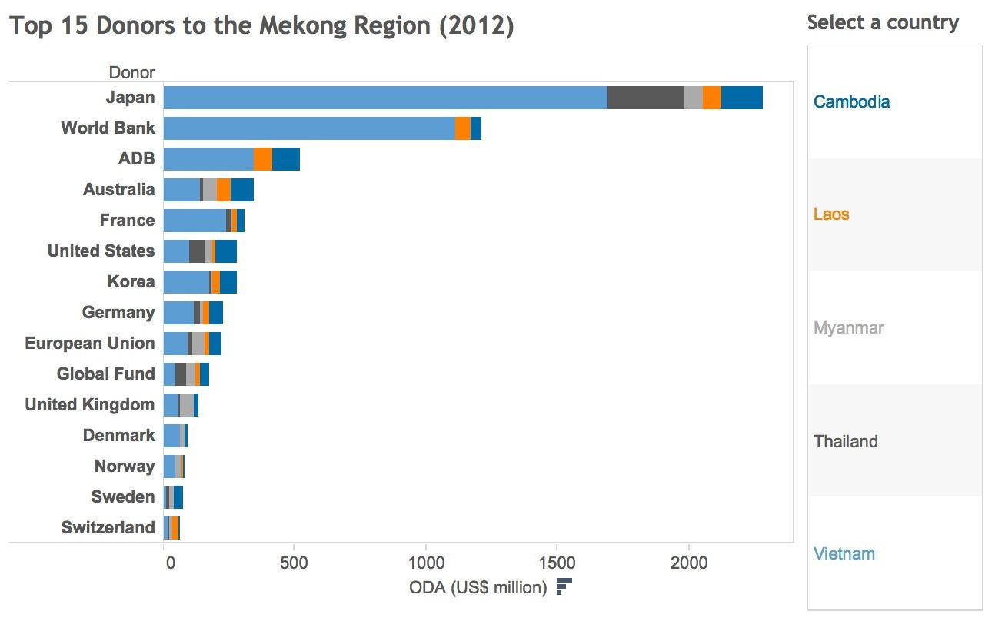*“Who are the biggest donors”* is answered both with bullet points *and* a Tableau visualization.[1] The bullet points present the answer at a glance for readers in a hurry who are quickly scanning the page, while the Tableau visualization allows for more interaction. Users can make comparisons between donors and countries.
* *“How important is donor assistance to countries’ economies?”* is answered with numbers as the percentage of a country’s GNI that comes from official development assistance. This puts assistance in terms of the broader economy. The ratio is given for each of the countries in the Mekong region and a comparison to the average ratio of ODA to GNI in Africa was given as well.

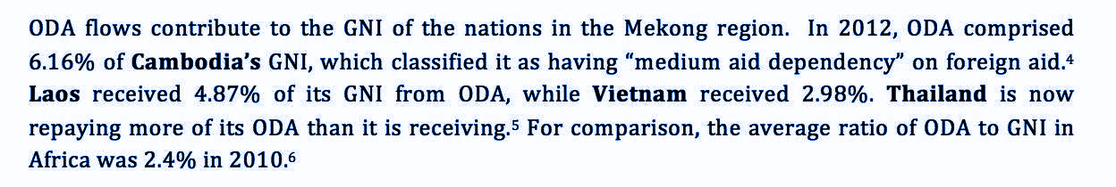

* 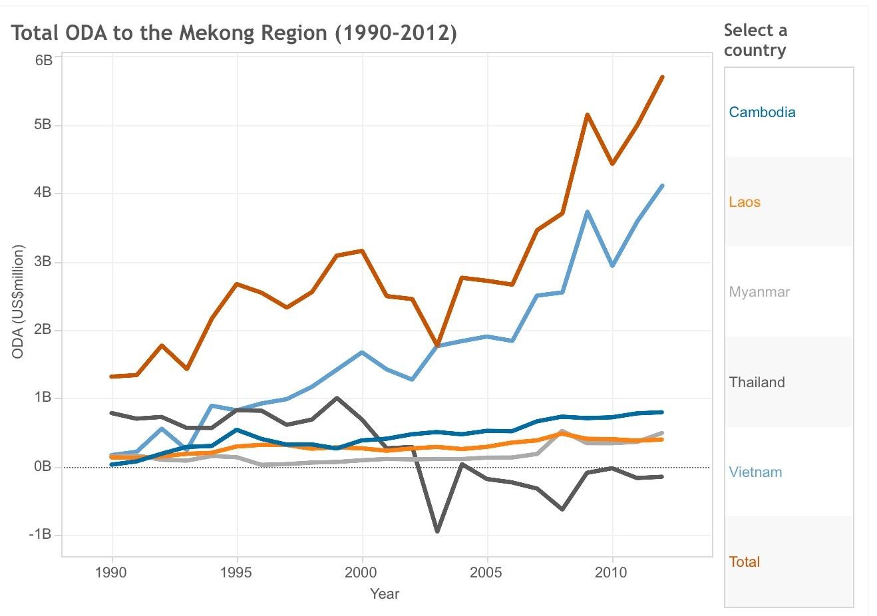“*How is ODA changing over time”* is answered with a time series graph.[2] This visualization is well suited for clearly illustrating trends over time and showing when countries start receiving more aid, or see a reduction in aid. Listing the years, amounts of aid, and countries would be cumbersome, but the visualization is clear. Explanations for certain trends are provided through text for added analysis.

In total, the overview page was only 500-600 words. Users can go deeper into the section to find more information, but the landing page provides only the most important information. The audiences’ most pressing questions are answered with bullet points, numbered lists, and visualizations to draw the eye.

**Donor Profiles**

The Donor and Development Assistance section will include profiles of the largest donors. Donor profiles provide an overview of the major multilateral and bilateral donor agencies working in the Mekong region. The profiles provide key information about the largest donors to the region: a brief background, focus sectors, major projects, regional and country-level strategy, and common critiques of the donor. These profiles can be longer than the landing page and go into more detail (1000-1500 words in length).

1. General overview
   1. Multilateral or bilateral donor? If multilateral, who are the members?
   2. When was the agency founded?
   3. What is their mission statement?
   4. Who does the agency give to?
   5. What forms of aid does the agency provide?
   6. What is the total funding provided by the agency?

II. External evaluations of the agency: what are others saying about the agency?

|  |  |
| --- | --- |
| ✓ Japan (JICA) | ❏ France |
| ✓World Bank | ❏ United States (USAID) |
| ✓Asian Development Bank | ❏ Korea |
| ✓Australia | ❏ Germany |
| ❏ China | ❏ European Union |

What are their strengths and weaknesses? Be objective.

III. Mekong Region Overview: does the agency have a regional strategy?

IV. Country strategies: for each country, describe what the major sectors are that are supported by the donor, key projects, total funding, and projections for funding over time. Highlight any projects done by the agency that have received media attention, for either positive or negative reasons.

In addition to text, be sure to include visualizations and/or tables to help summarize the data. A table with 3-4 key parameters is a good way to compare donor activity across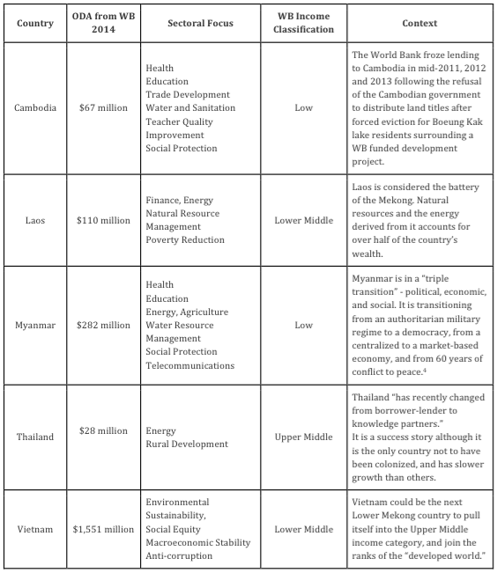 countries. Visualizations can help present numerical data. Infographics can help illustrate key processes of donor activity (such as the process of project design and implementation). Be creative with visualizations!

The SIPA Team completed four donor profiles. Profiles should be written for the ten largest donors:

1. View the interactive donor comparison visualization [here](https://public.tableau.com/profile/skipper4840%23!/vizhome/Top15DonorstotheMekongRegion/Dashboard1).
2. View the interactive time series visualization [here](https://public.tableau.com/profile/skipper4840%23!/vizhome/TotalODAOverTime1990-2012/Dashboard1)